A Thomas Ware

Capstone Project.

Solutions Calculator Club

Product Development Documentation

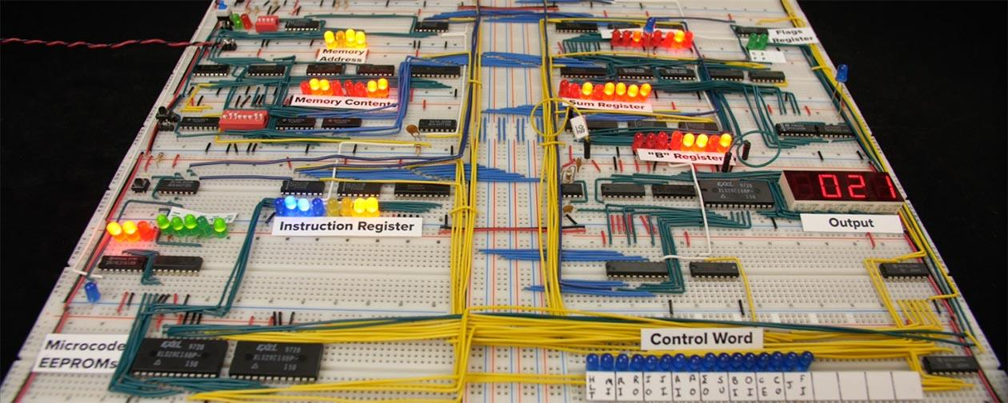

Ben Eater’s 8 Bit Computer